**SECTION : 01**

**GROUP 7**

**Member 1: Esaba Ahnaf Ibrahim (20301422)**

**Member 2: Labib Sadman Azam (21301643)**

**Member 3: Moinul Hossain Bhuiyan (20301002)**

The idea of the project stems from the moments of slow-paced life when the sun is at its zenith, while a pedestrian is passing by a car.

However, as the pedestrian walks closer to the car, the sun shifts left indicating a macabre situation and when the sun is at its leftmost position the pedestrian is hit by the car and the fate of the pedestrian is left to destiny. This is a project where we want to aware about accidents on the road and take measures to prevent accidents. Green was used because green symbolizes envy and this shows the envy to live more before being hit by a car.

Initially, the project looked like the illustration given below.

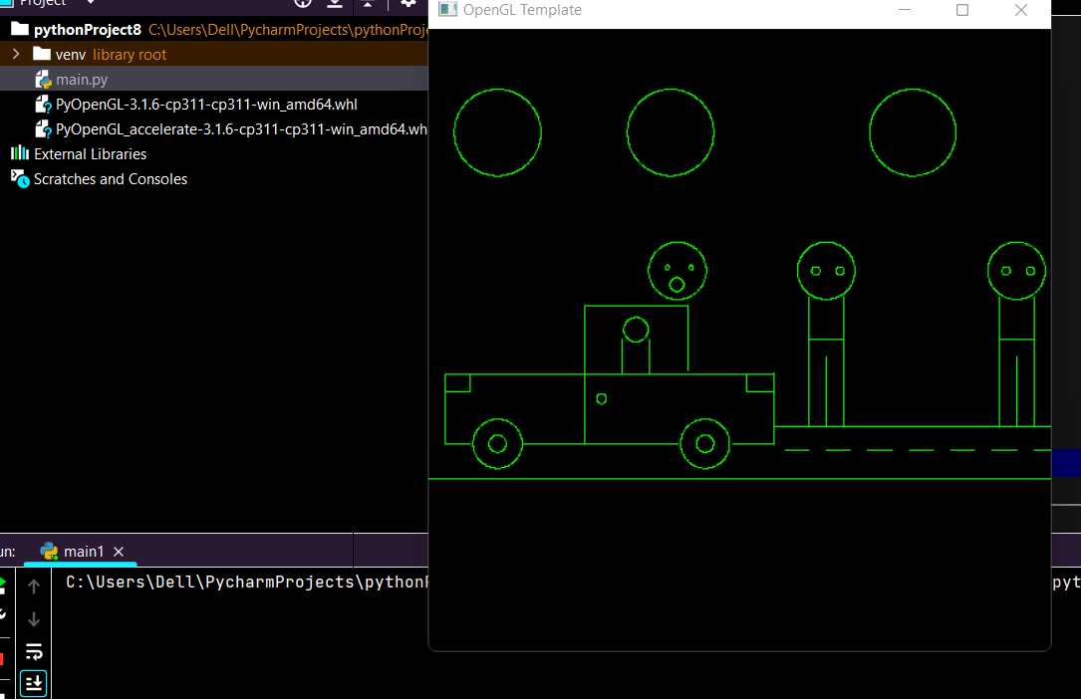

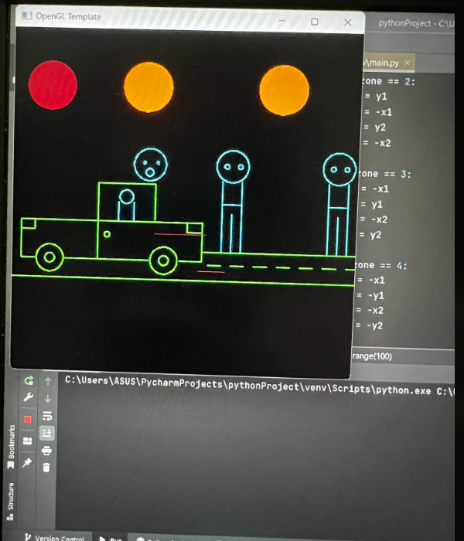

We then filled it with color providing vibrance to the project.

In order, to make the project more dynamic and user-friendly we prefer to display animation via user input..Thus, it transformed to the illustration given below.

**Scenario 01:**

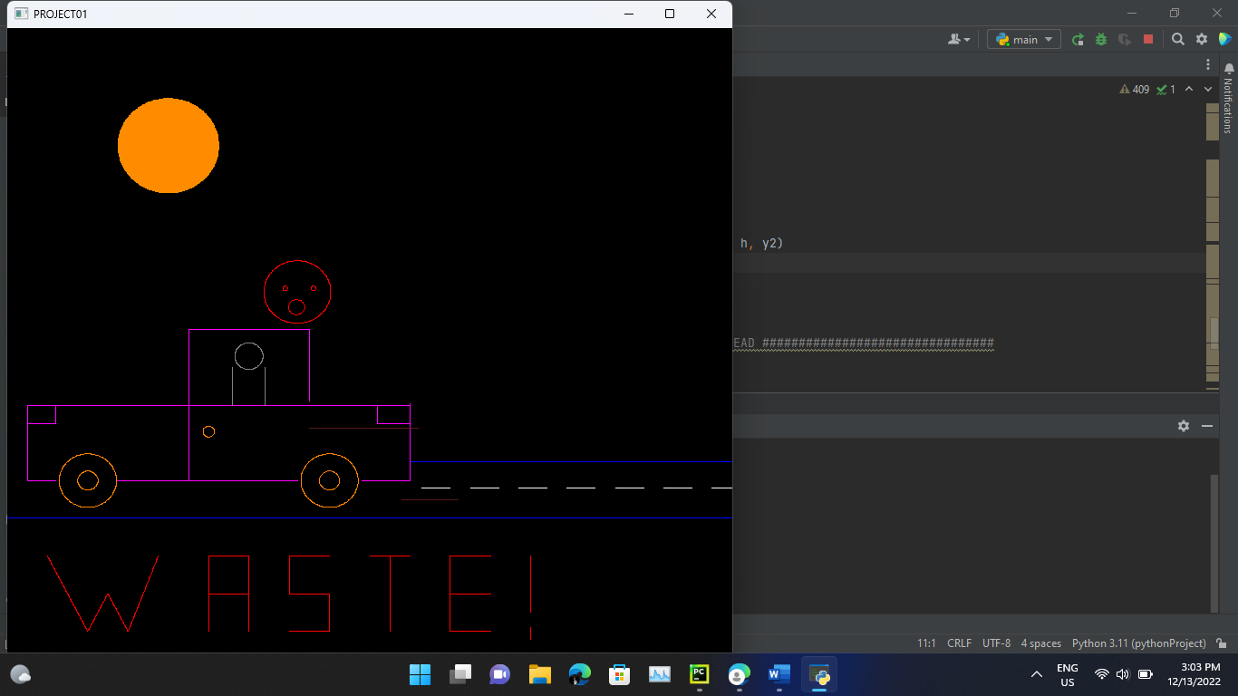

**Scenario 02**

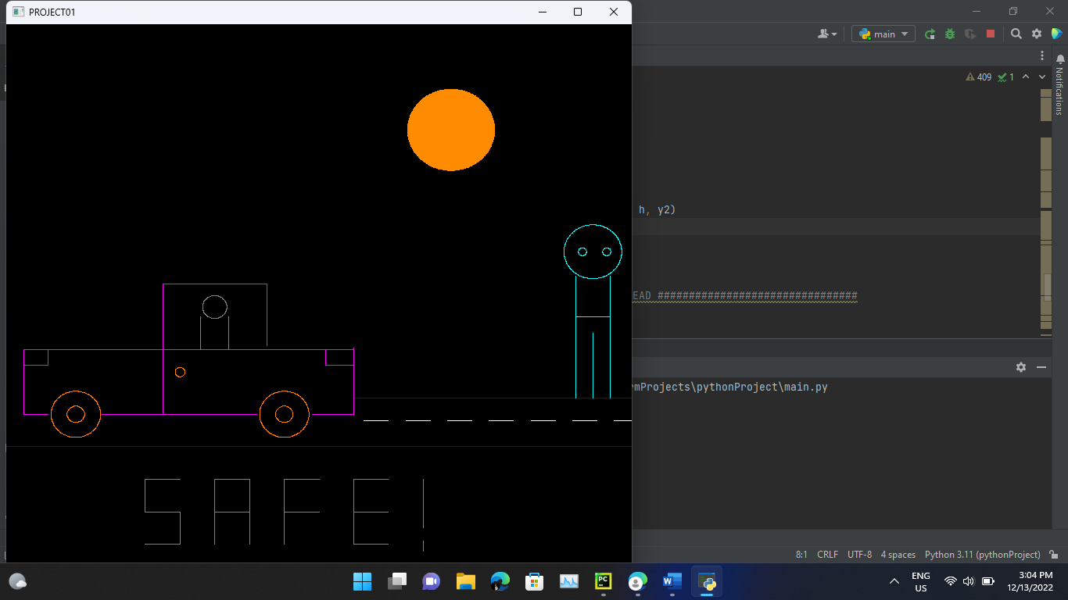

**Scenario 3**

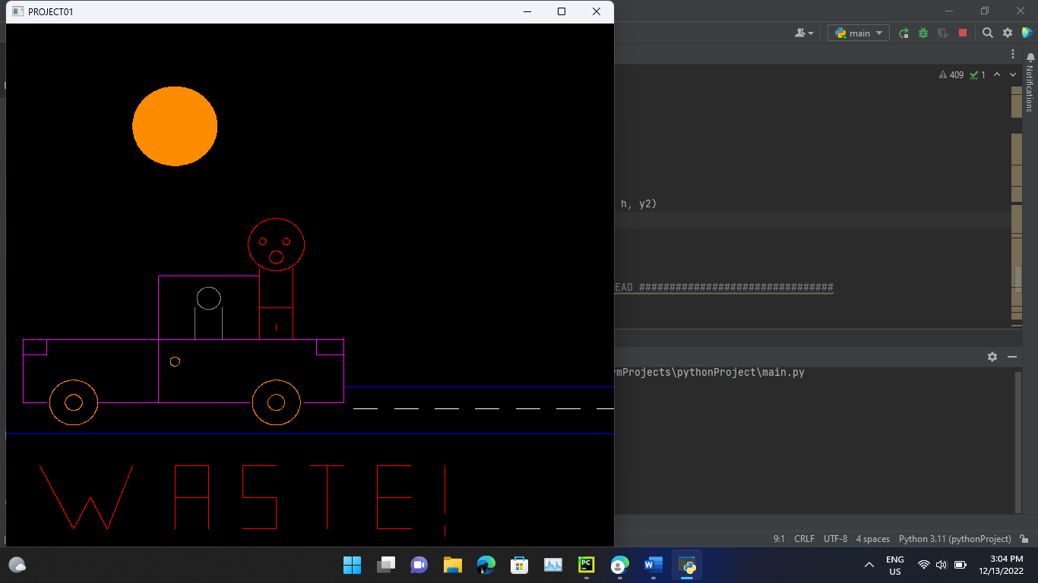

**More Test Cases**

